The Unites Nations is known around the world by millions of people, but not everyone knows what exactly the united nations actually do. The United Nations was created in 1945 to promote inter nation cooperation. This was created due to World War One and World War Two, there had to be some sort of system to keep everyone in check. The United Nations makes sure that all humans have the basic rights of living, and having an education is a huge part of human rights. “Article 26 of the 1948 Universal Declaration of Human Rights states that “everyone has the right to education”. Education is not only a right but a passport to human development. It opens doors and expands opportunities and freedoms”(Cite 1). Without education you are taking away a persons human right to grow within a society and be able to have a better life.
To learn about Irelands education system you should have some insight on what there education system actually looks like. In Ireland it is normal for kids to start their education path at the age of 6, even though a lot of children enter the school system after they turn four. All students must attend primary education then go on to take secondary education, In Ireland the secondary education is a little different then what is viewed in the United States. In Ireland, the secondary education consists of two cycles, a junior cycle and a senior cycle. The junior cycle starts at the age of twelve and lasts usually three years, at the end of the three year cycle the children have to take an exam to see if they can move on in their program. If they pass the children move on to their senior cycle which is also a three year cycle. Just like the junior cycle, at the end of the children's senior cycle they must pass an exam to see if they can graduate. At the end of their program they receive a “leaving certificate”(Cite 2). This allows them to finally be done with education if they choose so, they also may attend universities for extra learning.
Ireland has done a lot in the education field over its time as a country. As of 2012 the amount of children in primary schools is over 102 percent, this is due to their inclusion policies and children staying past the age of eighteen to finish their schooling. A lot of countries would love to have a rate of 100 percent of their children in the school system. This will help Ireland in the long run due to everyone being educated, there is so many benefits to having a social class who is well educated. “Ireland's long and honorable tradition in educational excellence is recognized the world over. Dating back to the middle Ages, Ireland held the position as one of the principal education providers to the western world”(cite 3). Modern governments in Ireland regard education as a key priority and an investment to the country. This has resulted in one of the highest education participation rates in the world today, which, in turn, has had positive implications for the strong economic growth and development of Ireland.
One major thing that Ireland has done for the rest of the world in the education field is how inclusive their education system is. Inclusion is an effort to make sure all students with disabilities go to school with their peers and age level. Ireland has been thriving in this field for numerous of years now. Inclusion has been a problem in a lot of countries, but Ireland has seemed to find the right solution to it. “The right to education is recognized under Article 42 of the Irish Constitution that guarantees an ‘absolute right’ to appropriate primary education (Association for the Severely and Profoundly Mentally Handicapped, 2001)”(Cite 4). This has been enacted by the Irish government to make sure that every child has a basic human right to education. Ireland is a primary example of how every country should be moving forward in the education field.

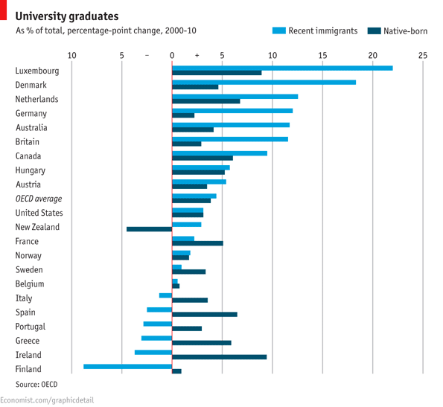
This Graph shows how Ireland is starting to send more students to universities. Ireland used to just simply have their students go through primary education and secondary education, not a lot of students went onto universities. This graph shows how Ireland is starting to becoming a primary source of education in our world.
This graph continues to show Irelands movement to go on to further or higher education. It is becoming more known in Ireland today that if students do not go onto higher education it is harder to find a high quality job.

Cites
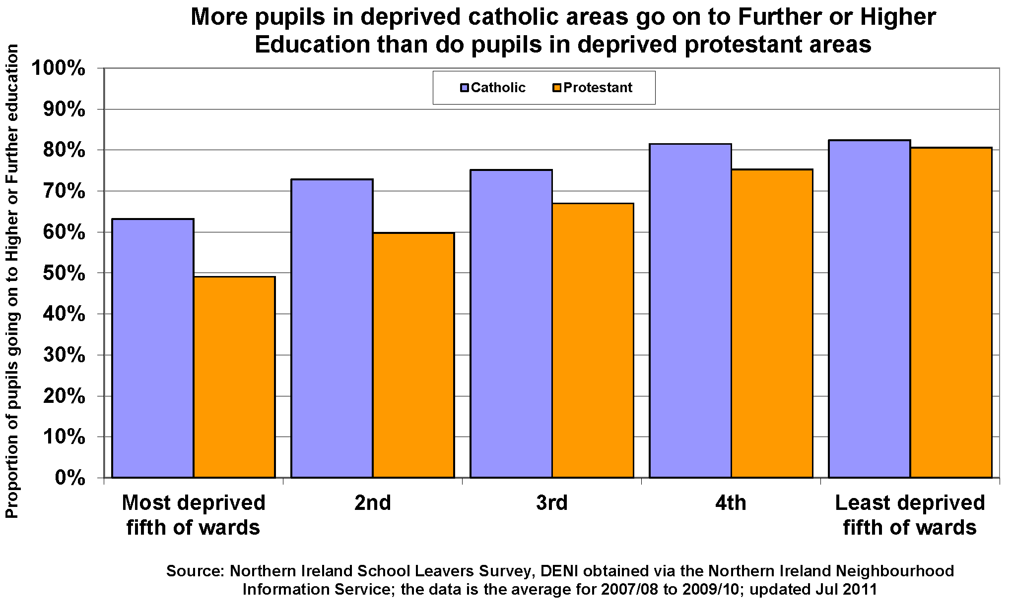
- Resources for speakers, global issues, africa, ageing, agriculture, aids, atomic energy, children, climate change, culture, decolonization, demining, development, disabilities, disarmament, environment, food, governance, humanitarian, refugees, women. (n.d.). Retrieved March 25, 2015, from http://www.un.org/en/globalissues/briefingpapers/efa/
- Post Primary Education. (n.d.). Retrieved March 25, 2015, from https://www.education.ie/en/The-Education-System/Post-Primary/
- Ireland. (n.d.). Retrieved March 25, 2015, from http://aspirationsabroad.in/aspirations-abroad-ireland.php
- file:///Users/Ryan/Downloads/Inclusive%20education%20(IES%202006)%20-%20Meegan%20&%20MacPhail.pdf

